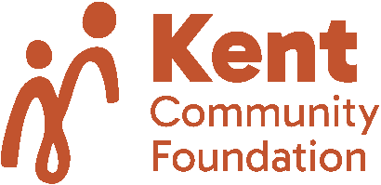

Local Development Fund

Guidelines November 2025

Purpose of the fund
This fund primarily supports organisations benefiting those most disadvantaged in society (especially children and young people) and is open to considering organisations active in the field of health and environmental conservation. The Fund focusses on strengthening charities, increasing their potential impact and encouraging long-term sustainability.
Applicants must show how they will use the investment to achieve significant, measurable outcomes, such as a new revenue stream or expansion of an already successful activity.

Who can apply?
Must be a registered charity that has been in existence for at least three years. Annual income over £100K. The Fund will only support organisations in robust financial health. The Fund will only support organisations with a demonstrably strong track record.

Geographical area of benefit
The county of Kent including Medway.

Grant size
Grants of £5,000 to £18,000. Grant request must be less than 10% of annual income. Grants will be one-off investments and not be awarded over multiple years.

General guidance
The Fund will prioritise grants which enable strong charitable organisations to reach new levels of achievement, efficiency and sustainability.
Th Fund has a focus on the capacity of charities, by which we mean the capability, knowledge or resources that charities need to be effective. Grants should focus on helping organisations strengthen their impact, effectiveness and/or sustainability - therefore strengthening their ability to achieve their mission. This could include investment in leadership, strategic planning, fundraising, financial management or impact measurement. Where appropriate, the Foundation may consider the refurbishment of premises where it helps organisations deliver services more effectively.
The Fund will not consider:
- Applications for core/running costs such as general salaries, marketing, training or event sponsorship.
- Applications from individuals, political or sectarian organisations, mainstream schools and colleges, playgroups, community centres, sports clubs. Religious groups can apply but their services must be open to all and the grant cannot be used for the promotion of religion.
- Applications for general repairs.
Please note that IT upgrades are no longer a priority.

Decision making
Applications will be considered on an ad hoc basis, usually within four months of being submitted.

Feedback/Monitoring required
Applicants must include in their application what impact they hope to achieve, and how this will be measured/evidenced. Grantees must complete an impact report at the end of the project period.

