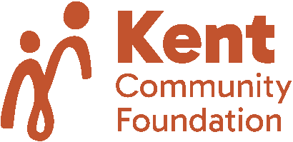

Development and Events Officer

Responsible to: Co-Head of Development

The Development and Events Officer plays a key role in delivering Kent Community Foundation’s donor engagement, fundraising and external events activity. This is a varied and collaborative role, supporting the Development Team to build strong relationships with donors, and working across teams to help deliver events that raise Kent Community Foundation’s profile, engage donors and partners and support the delivery of the communications strategy and wider business plan.

Key Responsibilities:

Donor Engagement, Prospect Research & Stewardship
- Support the Development Team in cultivating and stewarding relationships with donors, prospective donors, and corporate partners
- Conduct research to identify potential new donors and summarise findings for use by senior colleagues
- Draft and coordinate thank-you letters, impact updates and donor acknowledgements, ensuring communications are timely and personalised
- Assist in the preparation of donor facing materials including proposals, reports, and tailored presentations
- Ensure all donor interactions and communications are accurately recorded and tracked on Salesforce CRM

Event Planning and Delivery
- Plan, coordinate and deliver all external events, including cultivation, stewardship, and profile-raising activities ensuring support for the delivery of the communications strategy and wider business plan.
- Work closely with senior development colleagues, Head of Communications and senior grants colleagues to ensure events align with organisational priorities.
- Manage event logistics from start to finish, including venues, suppliers, guest lists, catering, AV, invitations, and post-event follow-up
- Collaborate with the communications team to ensure all event promotion and materials reflect our brand and values
- Track attendance and gather feedback to support post-event evaluation
- Ensure events are well documented and insights are captured to inform future planning

Administrative and Team Support
- Provide administrative support to the Development Team, including scheduling, taking minutes, and preparing briefing materials
- Monitor the development inbox, triaging initial enquiries and ensuring timely responses
- Maintain accurate records of fundraising activity, donor engagement, and events
- Prepare agendas and minutes for monthly development meetings and track follow-up actions
- Support additional tasks as requested by the Head of Development or Chief Executive in support of our wider organisational objectives

Person Specification
Essential
- Strong organisational and time management skills
- Excellent written and verbal communication skills
- Confidence using CRM systems (preferably Salesforce) and Microsoft Office
- Ability to manage multiple projects and deadlines with attention to detail
- A collaborative team player with a positive, can-do attitude
- Alignment with Kent Community Foundation’s mission and values
Desirable
- Experience of working in a fundraising, events or donor-focused role
- Understanding of the charity sector and/or community foundations
- Confidence working with a range of stakeholders, including donors, corporate partners and community groups

